**Uploading Task Manager Service in Git**

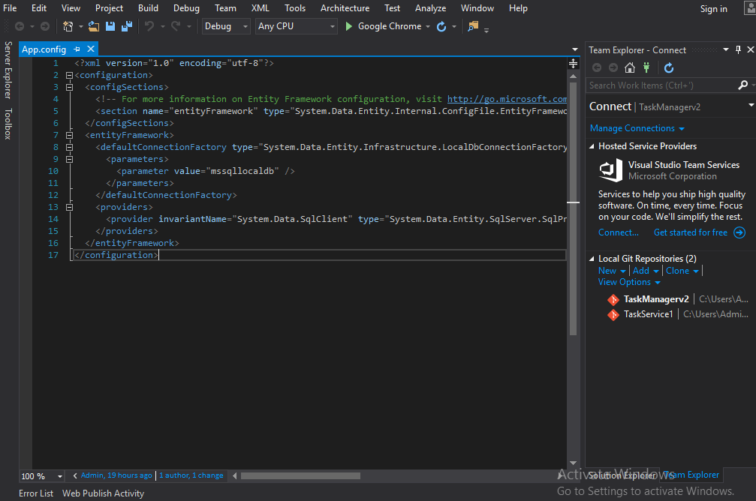

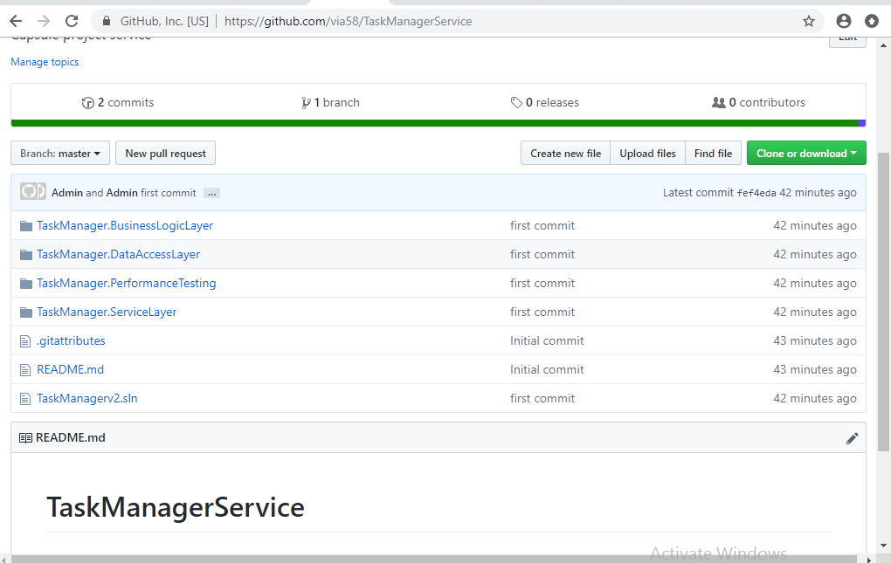

**Service Repository link:** [**https://github.com/via58/TaskManagerService**](https://github.com/via58/TaskManagerService)

**Uploading Task Manager Angular Project in Git**

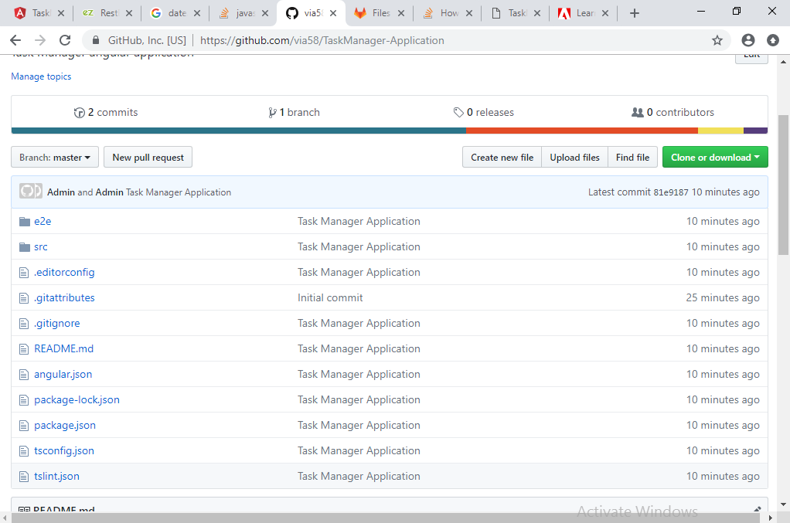

**Application Repository link:** [**https://github.com/via58/TaskManager-Application**](https://github.com/via58/TaskManager-Application)

**One Step Deployment using Visual Studio**

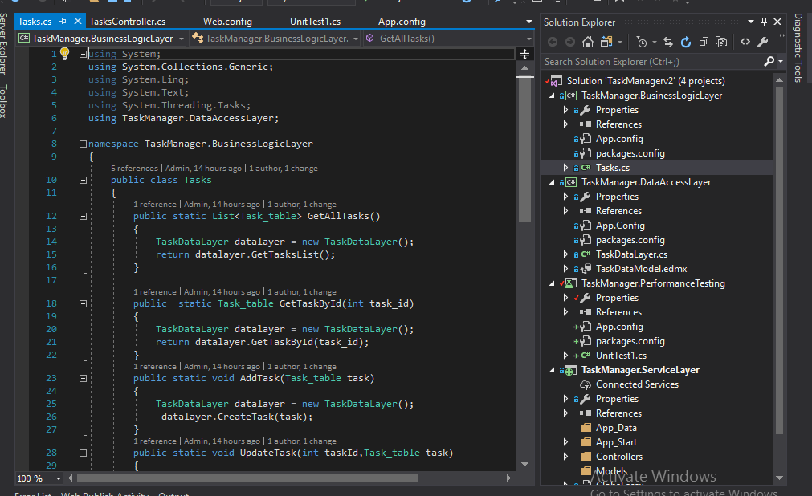

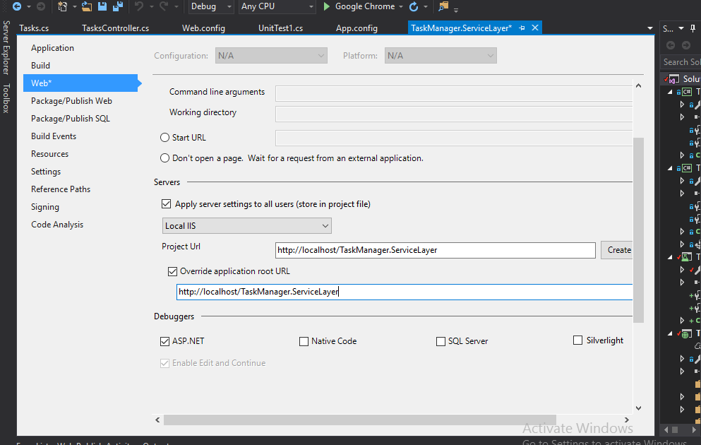

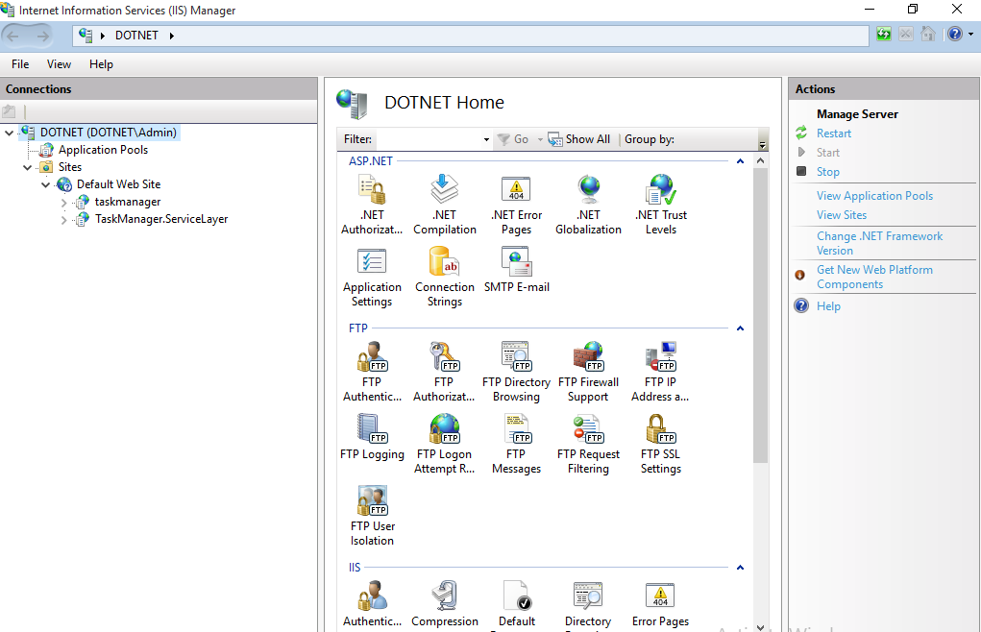

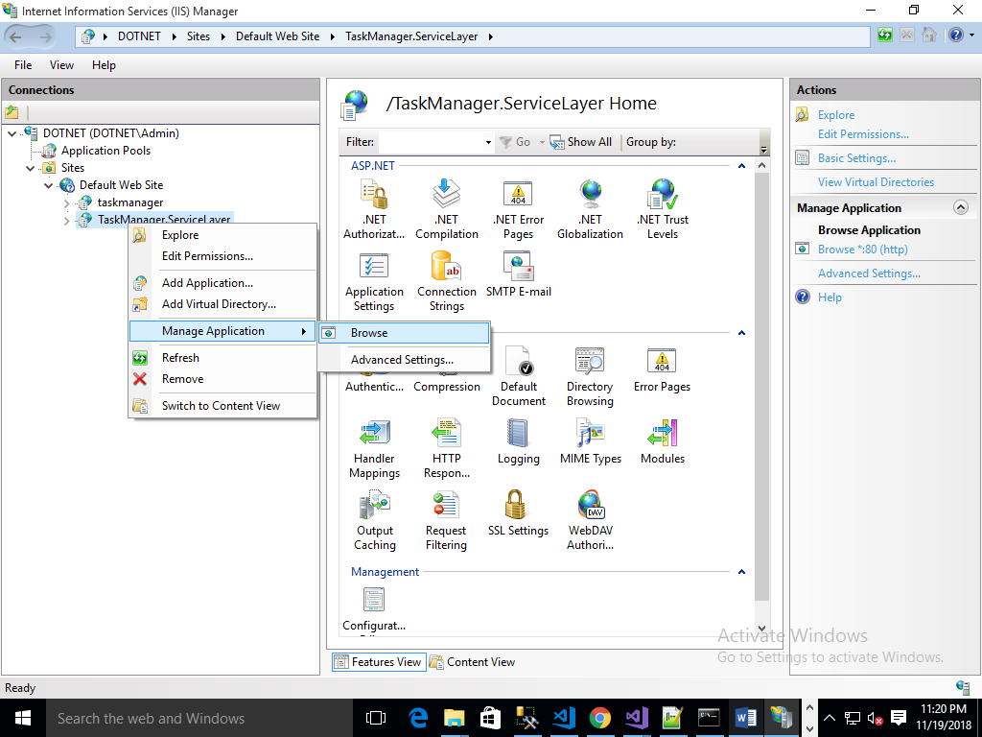

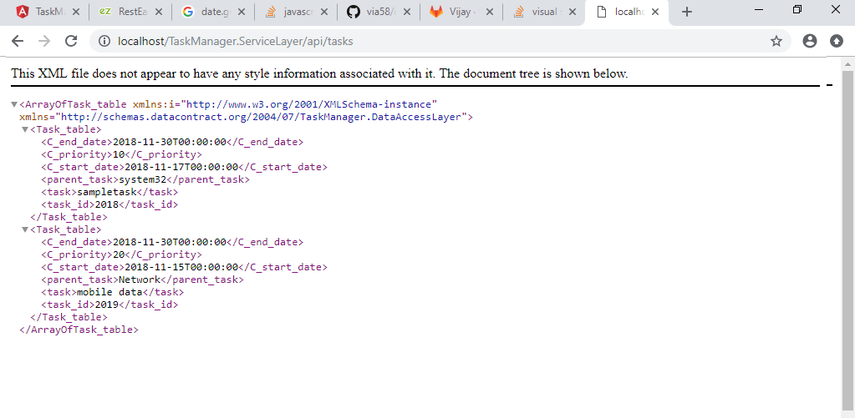

**Deploy Angular Task Manager project**

